27.12.2018



CONCEPTUAL DESIGN REPORT

Design Studio #4

Instructor: Gülbin DURAL

Members:

* Fatih ÇALIŞ
* Fatih ÇAM
* Recep GÜNAY
* Huzeyfe HİNTOĞLU
* Sarah ILYAS

**Table of Contents**

1.EXECUTIVE SUMMARY 3

2. INTRODUCTION 4

2.1. Problem Statement 4

2.2. Background 4

2.3. Organization of the Report 5

3. SOLUTION 5

3.1. Overall System 5

3.2. Transmission System 7

3.3. Mechanical Subsystem 13

3.4. Electromechanical and Power Subsystem 16

3.5. Control Subsystem 20

3.6. Sensor Subsystem 22

3.7. User Interface Subsystem 23

4. PLANS 23

4.1. Breakdown of The Planned Work 23

4.2. Gantt Chart 25

4.3. Difficulties and Solutions 27

4.4. Test Plans and Measures of Success 28

4.5. Integration Plans 28

4.6. Cost analysis 29

4.7. Deliverables 30

5. CONCLUSION 31

6) DISCLAIMER 32

7) REFERENCES 33

# 1.EXECUTIVE SUMMARY

Automata Technologies is a company formed by 5 passionate and intelligent engineers who are proficient in their respective areas. It was founded with only one purpose: to seek what is in the future and always innovate. We have been encountering more and more with projects integrating robotics and sports every day. However, we have never seen a project implementing hockey game with robots and we have seen a very big opportunity there. We, as Automata Technologies, are inspired by these developments and have started a new project which will create new possibilities for the future of sports industry.

We will design a robot which will play hockey with a similar robot on a standard hexagonal play field. The robots are to be teleoperated by players from up to 30 meters distance via transmitted images. Although the game sounds simple to play, the design and implementation of the project requires the integration of low latency video transmission and control commands, strong but low power shooting mechanism, smart defense and attack tactics and low cost but effective design choices. However, as Automata Technologies with our intelligent and passionate engineer team, we can overcome all these issues and complete the overall project with success in time by applying efficient and effective labor division, teamwork and integration of the individual knowledge among the company.

The problems to be solved are specified as follows: transmission of the first person video of the robot, transmission and executing commands, mechanical implementation of the robot and obstacle avoidance. We have proposed several solution methods to each problem and will research on the implementation of these solutions considering budget, feasibility and robustness.

* The main solution plan for the video transmission is using FPV transmission system which consists of a camera with NTSC output, a powerful video transmitter and a diversity type receiver combined with a display screen.
* The main solution plan for the shooting mechanism is using a spring system which consists of a rough spring, a servo motor to compress it and a platform to shoot the ball.
* The main solution plan for the transmission and execution of commands is to use an RF transmitter and receiver module integrated with a microcontroller.
* The main solution plan for the control of the robot is to combine various sensors such as IMU, obstacle avoidance and line follower with a microcontroller.
* The main solution plan to drive the robot is to use two wheels connected to motors and one free wheel using differential drive.

This document is a proposal for the mentioned product and contains the design and implementation procedures of the project. With scheduled hard work, our product will be ready on time without exceeding the budget as proposed in this document.

# 2. INTRODUCTION

## 2.1. Problem Statement

First and foremost, it is important to delineate and identify the elements that are crucial to the execution of this project. The task at hand calls for a comprehensive and creative solution to the given problem. It is only by virtue of a clear assessment of the demands of the customer that we can follow through on and effectuate what is expected of our company. This project entails the design of a sophisticated system that meets the standards and requirements that have been laid out. Firstly, a communication system between the robot and the operator is the bedrock of this project and therefore is of prime importance. As stated in the requirements for the project, there should be a distance of at least 30 metres between the robot and the operator. Moreover, the robot of each team should be confined to only one half of the entire playing field and should not be in possession of the ball for longer than 20 seconds.

## 2.2. Background

Since this project is inherently mimicking a recreational sport, it holds immense potential to be implemented in actual settings by players in a wide age group. Most importantly, it can be implemented in settings where a player has physical disabilities and cannot perform the actual sport out in the open but can partake in it in a somewhat virtual setting. A case in point is Amyotrophic Lateral Sclerosis patients who have very limited motor control. By virtue of this project, however, they can achieve satisfaction that may be comparable to that achieved by playing the actual sport. Also, like any other sport, this sport, in a virtual setting helps sharpen the reflexes of the players; but unlike real sports which may be disrupted by unfavorable pitch conditions owing to rain or other similar environmental conditions, this one will not be impacted by external circumstances or environmental conditions. In addition, this project is also ideal for children who can learn the tricks of the trade for the game earlier on, before setting out on the field.

## 2.3. Organization of the Report

This report aims to lay out the groundwork of the disparate parts of the assigned project for our company. Through this document, we, at Automata Technologies wish to elucidate and illustrate the headway that has been made with regards to meeting the client’s demands and expectations for this project. As a client- conscious firm, we believe that it is indispensable that our customers and clientele be cognizant of the progress made. Thus, this report aims to highlight the solution procedure that has been worked out and the subsystems fashioned in order to achieve the desired objectives it also serves to underscore the plans that we aim to realize for the fulfillment and accomplishment of this project. Thereafter, a tentative cost budget analysis will serve to apprise and inform our client about the budget allocation for each subsystem of the project. In a similar vein, a Gantt chart will help our client be in step with the intended scheduling for the project.

# SOLUTION

## 3.1. Overall System

**Description:** The robot in this project is a tele-operated robot that tries to score by pushing or hitting a ball into the opponent’s goal, directly or indirectly. The operator remotely controls the robot (from a distance up to at least 30 meters) without actually monitoring the play-field with naked eye; the only means of monitoring the field is by means of a camera mounted on board the robot. In order to have reasonable solutions for the problems, the system must be analyzed with dividing it into subsystems so that the overall system can meet all the requirements.

The system is composed of six subsystems that are Transmission Subsystem, Mechanical Subsystem, Electromechanical Subsystem, Control Subsystem, Sensor Subsystem and User Interface Subsystem. The block diagram that shows the connection types and the connections between the subsystems are shown in Figure1.

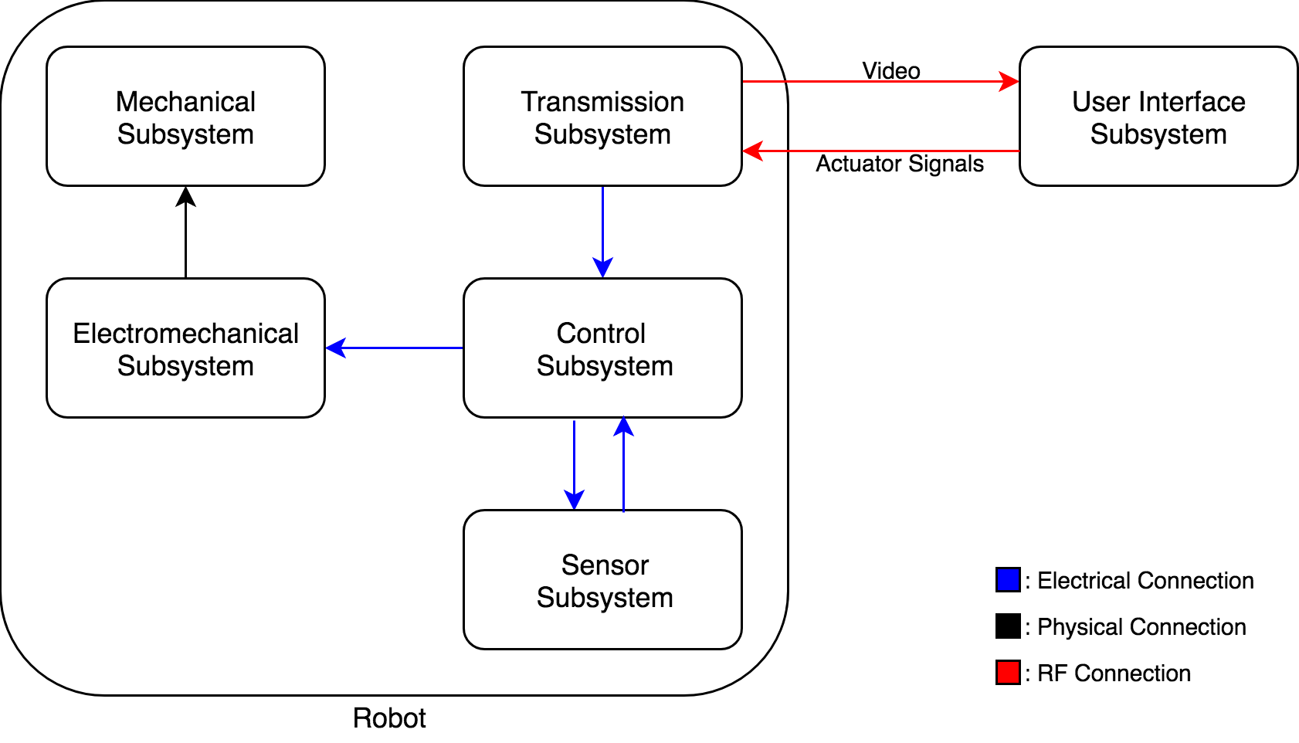

Figure 1: Overall description of the system with a block diagram including sub-system interaction and interfaces

The operation of the robot can be classified into 2 modes: Attack mode and the Defense mode. Although most of the operations in these modes are the same, to simplify and improve the control of the robot, some minor differences are to be implemented. The user will switch to these modes by using a button on the RC transmitter.

In both modes, the FPV camera will stream the video that is seen by the robot to the monitor. The user will try to control the robot by watching the live video and by using a RC transmitter. The user will be able to control the speed and rotation direction of the robot via one of the joysticks of the transmitter and control the angle of the FPV camera via other joystick. The shooting mechanism will be activated by one of the switches of the RC transmitter.

In attack mode, the user will try to get robot move forward and aim to the opponent’s goal. After that, the shooting mechanism will be triggered and the robot shoots. In the defense mode, the robot will rotate 90 degrees to be able to save its goal more effectively and the FPV camera will rotate to the other direction by 90 degree to see the ball in a better wat. In this mode, the user will have a more chance to prevent its opponent from a score since the robot will be able to move forward and backward faster than the attack mode. The general operation flowchart of the robot is shown in Figure2.

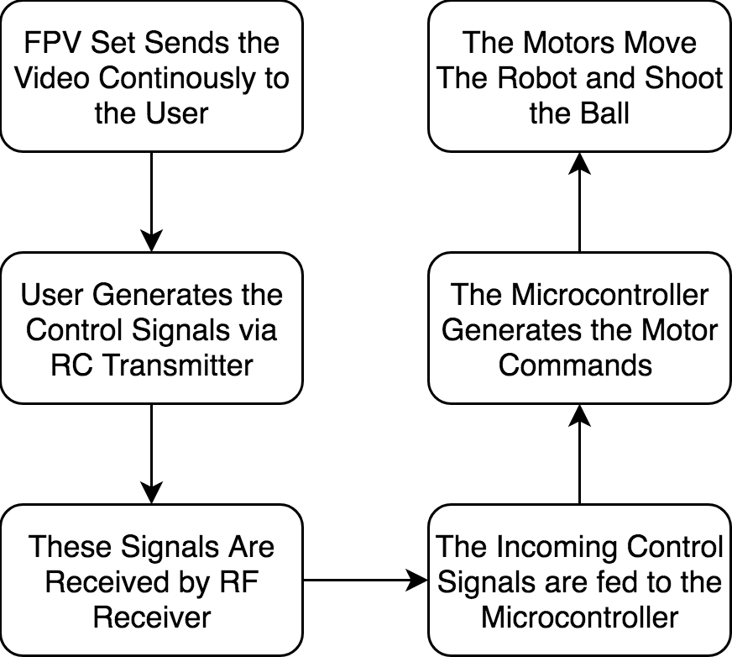

Figure 2: The main operation flowchart of the system

## 3.2. Transmission System

### 3.2.1. Problem Statement and Requirements

In this part, we are required to receive information about the surrounding of the robot wirelessly from up to 30 meters when there are obstacles between the robot and the user. This information transmission can be via video transmission, discrete image transmission or information resulting from image processing. There is no limitation on the nature of the transmission other than it can not be via Wi-Fi protocol and the groups should characterize their communication links so that the interference among different groups is avoided.

### 3.2.2. Main Solution Procedure

As mentioned before, the operator will control the robot from a distance up to at least 30 meters. Therefore, among the possible solution methods listed above, we choose as our main solution that the operator will monitor the field by camera mounted on the robot. This requires live video stream with enough resolution and low latency for proper operation. The solution for live video stream is FPV camera set. An FPV camera set is composed of a camera, an analog video transmitter with antenna, and a receiver. Since, the FPV cameras work on analogue video, their resolution is measured in TV lines or TVL rather than pixels. There are some options for TVL such as 420, 480, 600, 800 and 1000. Latency is another factor, which highly depends on both the distance and the quality of the transmitted video. It is usually around 50ms, which is ideal for our project. The transmitter basically processes the image that is captured by the camera and encode this data into an analog signal with a high frequency. The most commonly used frequencies by FPV cameras are 900MHz, 1.2GHz, 2.4GHz and 5.8GHz. Considering the obstacles that will be put on the area, 5.8 GHz is convenient for our project to transmit live video. The receiver decodes the signal that is radiated by the transmitter and convert this data into a displayable format. After this conversion, a screen is used to convert the data into a video. The screen is a smartphone or an AV monitor. The overall block diagram of the transmission subsystem is shown in Figure3.

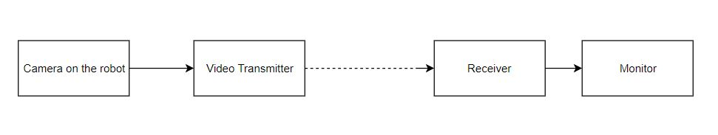

Figure 3: The block diagram of the transmission subsystem.

For the video transmission purpose, our main plan is to use FPV transmitter, receiver and camera. One of the most important specification of the video transmission is the transmitter output power. The transmitter output should be powerful enough so that the video signal can penetrate through walls up to 30 meters. However, it should be at the minimum power specification so that it will not cause a lot interference when reflected from the walls, it will not be unnecessarily expensive, and it will not cause interference for the other teams that might be using a similar set-up. The transmitter also has many channels in the bandwidth to choose from in order to differentiate the video signal from the signals of other teams. In order to meet the requirements about the range, we can increase the transmitter output power. In theory, in order to double the range, the transmitter output power should be quadrupled since the power is dissipated in other directions from the target direction.[1] However, the range dependence on the transmission power will even be less in practice due to noise and attenuation in all directions , and also increasing the transmitter output power may cause other issues such as overheating of the transmitter module, interfering with other teams and multipath interference caused by the waves reflecting from the obstacles. In order to solve the multipath interference problem, circularly polarized waves are utilized in the transmission.

The video receiver is also a very important factor in the video transmission system. A good receiver has a high sensitivity of signal power. Furthermore, we have decided that we should use a diversity type receiver for the continuity of the transmission since a diversity type receiver has two receiver modules inside. The two receiver modules have separate antenna inputs and the outputs of the receivers are compared according to the received signal strength[2]. The output of the receiver modules which has the greater strength is connected to the output of the overall circuit which feeds into the monitor. The operation principle of a diversity receiver is shown in Figure 4.

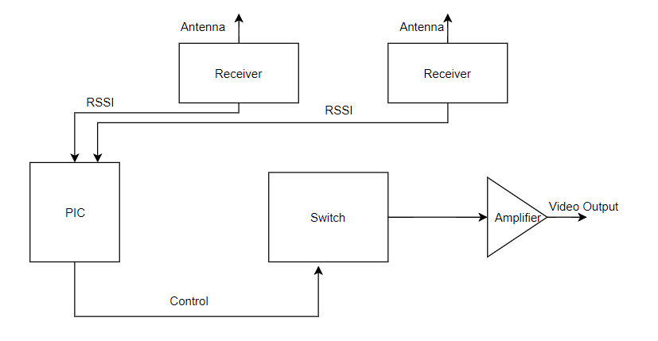

Figure 4: The block diagram of a diversity receiver.

Even though the diversity receiver system seems very sound in the operation, it has some flaws such as when the input antenna is changed, there might be a cut in the video for a short duration and the phase difference between the signals received from two antennas since there is a finite distance between the antennae. However, these issues do not cause much of a problem for the overall operation since the speed of operation is negligibly small compared to the magnitude of these problems.

The other important parameter of the video transmission system is the antennae namely, the antenna of the transmitter and the antennae of the receiver. We are using circularly polarized antenna in the system since the polarization direction changes when a circularly polarized electromagnetic wave reflects from an object. The antennae on both the transmitter and receiver are of the same polarization direction that is right hand circularly polarized(RHCP) or left hand circularly polarized(LHCP) so that the wave portion that reflects from an object does not cause an interference since the antenna ignores a wave with another polarization direction. Furthermore, the antenna on the transmitter is of omni-directional type giving equal amount of gain in all directions since the robot will move in different directions and the wave will propagate from different directions. The advantage of using a diversity receiver comes out at this point since we have the capability of using two antennae on the receiver. We use one omnidirectional antenna and one directional antenna with a relatively high gain in order to have gain in all directions and a high gain in direction to increase the gain in that direction[3]. The radiation patterns of an omni-directional antenna and a directional antenna are shown in Figure5 and in Figure6, respectively.

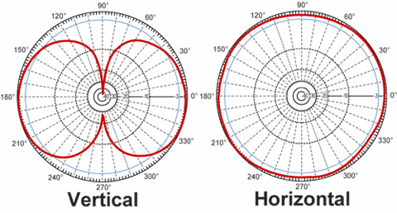

Figure 5: The radiation pattern of an omni-directional antenna.

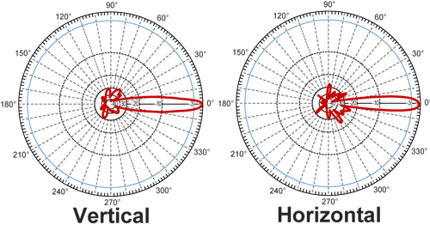

Figure 6: The radiation pattern of a directional antenna.

The camera used in the system is also very important since the quality of the displayed image depends on it. The camera we have experimented and demonstrated with is a high-quality camera costing 25$. Although the demonstration was very successful since we had a high-quality video on the monitor, we are prompted to experiment with other cameras out of budget and viewing angle considerations. We have bought a camera with wider angle of view and less costly to view more part of the field at one time to reduce the movement of the camera. If we have a camera with wide enough angle of view, we will not need to rotate the camera at all during the game. The monitor will be either an AV monitor or a smartphone according to the experiment results and budget considerations later.

### 3.2.3. Test Results and Alternative Solutions

The modules in the main solution plan of the transmission subsystem are all tried in various experiments. We have a 2000mW video transmitter, a diversity receiver, an FPV camera and an AV monitor in our possession. We have experimented with this setup many times in varying environmental conditions and the results satisfy the requirements. Also, we have demonstrated with this setup as a proof of concept and earned the approval of our design coordinator. In this part, the experiment result for each module and the plans for these modules according to the results are summarized.

We have experimented and demonstrated that we have clear, continuous and low latency video transmission with a 2000mW transmitter. The experiments are performed inside buildings where there are many walls between the transmitter and the receiver and the results are satisfying since the video transmission continued until and after 30 meters of distance. The same results were obtained when the experiment is performed outside in different weather conditions and obstacles such as buildings and trees were between the receiver and the transmitter. As mentioned in the previous part, a transmitter with too much output power might cause overheating and interference. For this purpose, the transmitter propagates a circularly polarized wave through its antenna. In order to solve the overheating problem, heatsink and cooling fan are utilized in the transmitter module. Although we know that more output power means more range, we want to experiment with less powerful transmitters due to budget constraints and interference with other teams. Therefore, we have bought another video transmitter with selectable output power options from 25mW to 600mW. We might obtain better range with a less powerful transmitter and a better antenna. We will experiment with this transmitter too and will decide on which transmitter to use according to the experiment results.

The receiver that we experimented with is of diversity type and we have proved that the system works fine with this receiver in the demonstration. The receiver combined with the monitor is very successful in that it did not suffer from any of the problems listed in the previous part. The image on the monitor is very clear and has a negligibly small delay meaning that it does not affect the overall operation in any way. We have measured the latency of the system by transmitting the video of a timer and observing the time on the monitor and with naked eye in different conditions. The delay when there is no obstacle between the receiver and the transmitter and there is a distance of 10 meters between them is about 10ms. The maximum delay occurs when the distance is up to 30-40 meters and there are some walls between them and it is 50ms. Therefore, even the maximum delay can’t be distinguished easily with the naked eye meaning that the operation doesn’t suffer from these delays. However, the video output of this receiver is television signals such as NTSC or PAL meaning that we need an AV monitor to display the video which adds to the cost of the project. Therefore, we have bought another FPV receiver which also has dual antenna system giving an output that can be displayed on smartphones. This receiver doesn’t have two receiver modules instead it has two antennas and the switch to decide which antenna is better receiving is before the receiver module. This might cause some problems such as two signals received from the two antennas might cancel each other out in a small fraction because of the separation between the two antennas causing phase difference between them. However, the sensitivities of the receivers are very close and this problem can be solved by placing the two antennas in the right positions, so we are expecting successful experiment results in the future.

We have performed our experiments and the demonstration using all omni-directional antennae and the results were very promising. We have bought better antennae with higher gains and hopefully we will improve our range and video quality. We can always also increase the range by pointing the receiver towards the robot to ensure that the receiver uses the input of the directional antenna. We can obtain a radiation pattern which is the combination of the two shown in Figure5 and 6.

Aside from the main plan for the video transmission, we are considering two other methods to obtain directions to control the robot. One solution is only transmitting information about the direction and distance of the opponent, walls, the ball and goal and middle lines using image processing on board the robot. This solution will not suffer from any bandwidth problems in the video transmission but will probably suffer from latency. This is because image processing with a control card in our limited budget is a really slow process and the received information will also have to be converted into meaningful information to understand what is transmitted. The other solution method can be using GSM operators to upload the video on the internet and downloading it on the receiver side. This method can overcome any distance and obstruction issues since the video can be uploaded and downloaded anywhere at any time. The drawback of this method is due to budget since uploading and downloading the video and integrating a GSM operator with a controller are very expensive.

## 3.3. Mechanical Subsystem

### 3.3.1. Overall Design of System

The desired specifications for the mechanical design are as follows:

* The FPV camera should have a good angle of view
* The components with high power consumption should have a direct contact with air
* The transmitter and receiver should be placed far away from the battery
* The motors should be placed such that they have minimal interaction with the ball
* The shooting mechanism should be close to the ground for a better shoot
* The shooting mechanism should have a good grip

According to the desired specifications, our final design for the robot is shown in Figure7.

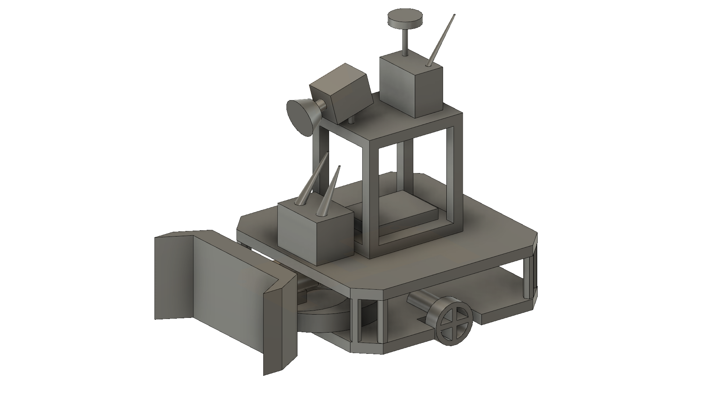

Figure 7: The 3D CAD drawing for the final design of the robot

### 3.3.2. Shooting Mechanism

While deliberating on the choice for a suitable shooting mechanism, we all found it imperative to weigh the pros and cons of each option.

There are 2 ways to obtain variable shooting power; by varying the springs displacement or by taking energy away with a variable damper. Using a variable damper, such as solenoid-based shooting mechanism, can be a good solution for controlling purposes. However, it demands too much energy which we cannot supply to the robot with the battery on it for a long time.

A shooting mechanism that employs a spring can be very powerful because, depending on aptly selected parameters, a spring can store inordinate amounts of energy. A system such as this would therefore be able to shoot the ball with high velocity. Moreover, the number of shots that can be made by virtue of this setup is almost unlimited because it is powered by a battery. On the other hand of the spectrum, however, the system also has its setbacks, it may be difficult to implement it mechanically and takes a while to reload. When the power consumption is considered, these are the problems can be solved easily rather than energy problem. As a result, a mechanical shooting mechanism, namely spring-based shooting mechanism, will be implemented onto the robot for these reasons. The Figure8 below depicts the general structure of a spring-based shooting mechanism

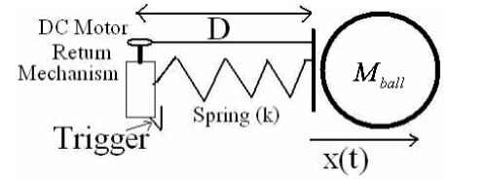

Figure 8: Spring based shooting mechanism working principle

There will be a triggering component, a DC motor, to compress the spring and store energy onto it mechanically. When the triggering command come by user, it starts to operate. After the required turn is made on motor, it suddenly releases the spring and as a result shooting is achieved. Shooting power and velocity of the ball will be tested and the mechanism can be optimized easily by changing either the position of the motor and rails or the length and material of the spring accordingly.

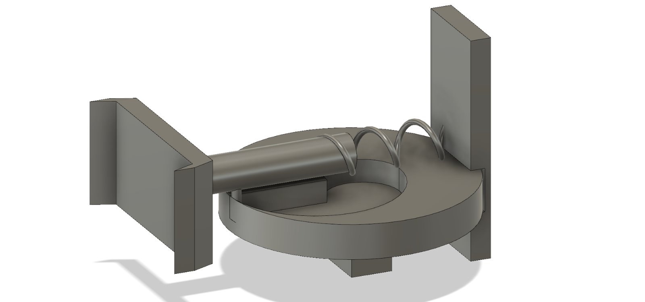

Figure 9: 3D model of shooting mechanism #1

The 1st alternative utilizes a spiral shaped mechanism. As the spiral rotates with the step or servo motor, the spring is compressed until the spiral completes full 360-degree rotation. When it completes its rotation, the spring is released, and the force is created. This option is depicted in Figure9.

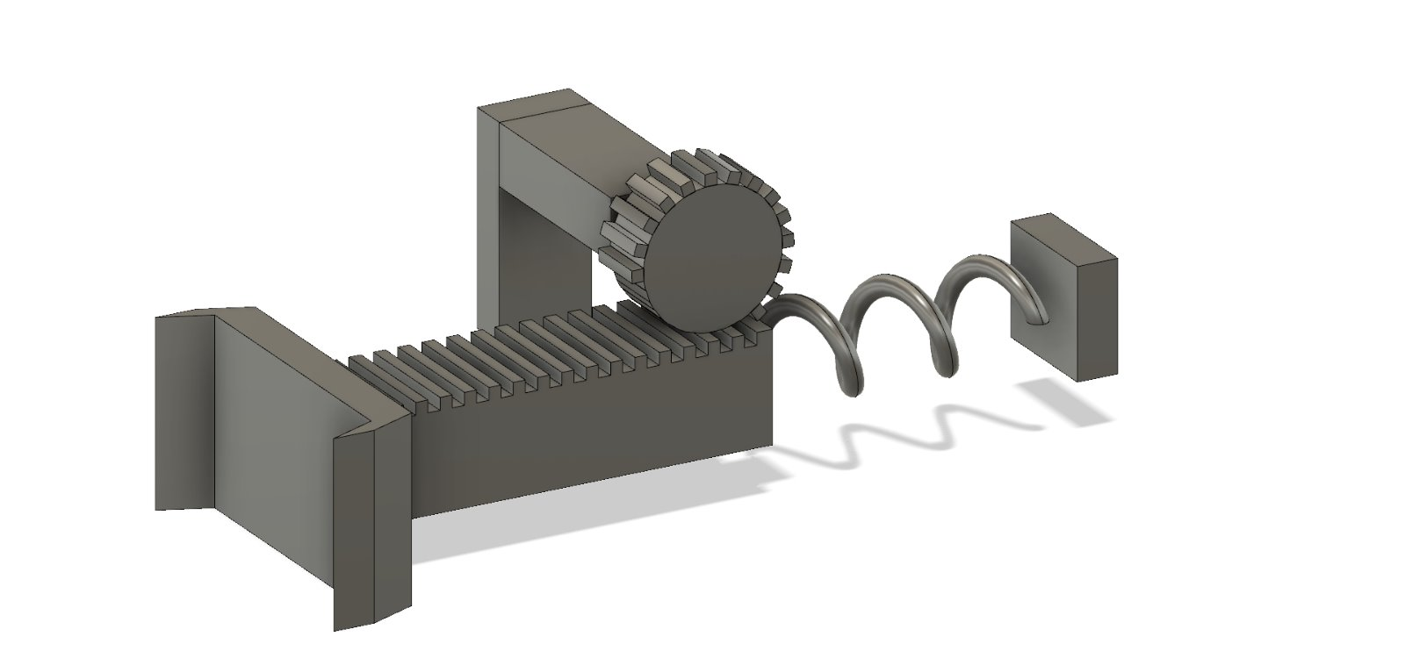

Figure 10: 3D model of shooting mechanism #2

The 2nd alternative utilizes a rail which is free to slide in one axis and a gear with some broken cogs. In this case, a DC motor rotates the gear and slides the rail resulting in a compression in the spring. When the gear rotates until the broken cogs is aligned with the rail, it releases the rail and thus force is created. This option is depicted in Figure10 .

## 3.4. Electromechanical and Power Subsystem

### 3.4.1. Problem Statement and Requirements

In designing of the electromechanical part, we need to consider the agility of the robot as it should react faster both in defence and attack modes. The robot should have the ability to rotate around itself and move around the play-field freely in order to align its direction and position according to ball and the position of the opponent robot. Robot is required to move in its own half-field in the regular hexagonal typed game field. The robot needs to move fast and shoot the ball quickly since the opponent tries to defend the ball or shoot the ball into our goal and the time of possession of the ball is limited with 20s.

### 3.4.2. Main Solution Procedure

Electromechanical subsystem is composed of motors and motor drivers. Basically, it is responsible for moving parts of the robot. For instance, movement of the overall chassis, alignment of camera on board according to position of the robot and shooting mechanism control and movement.

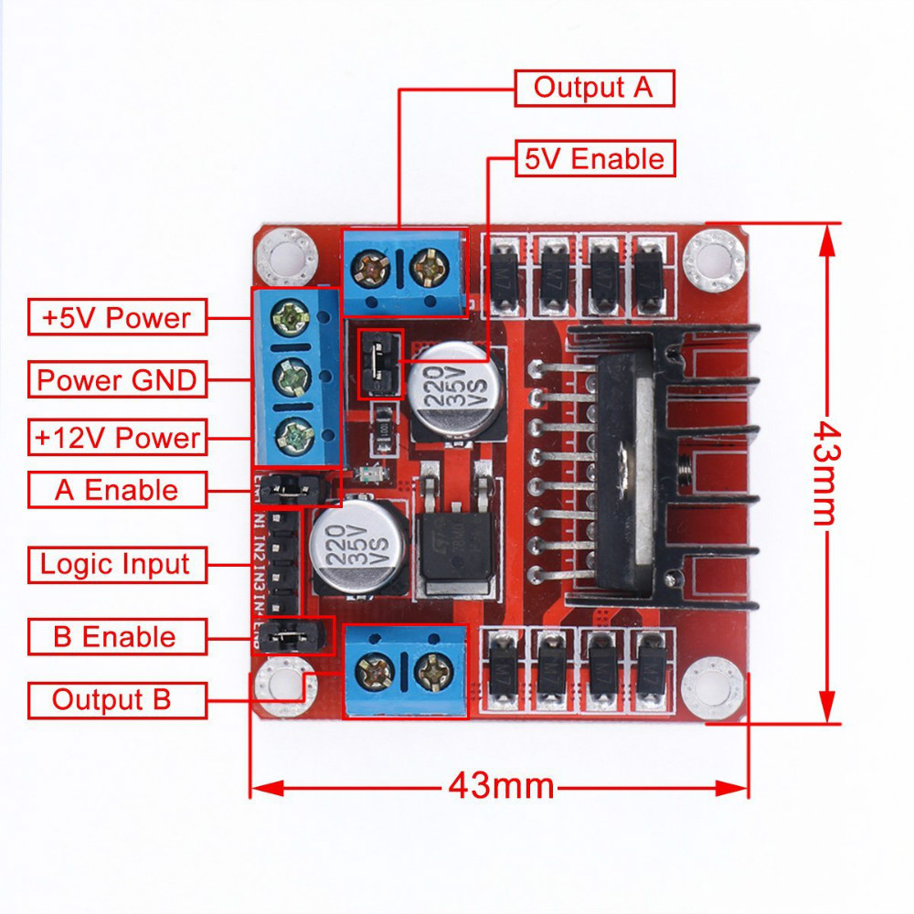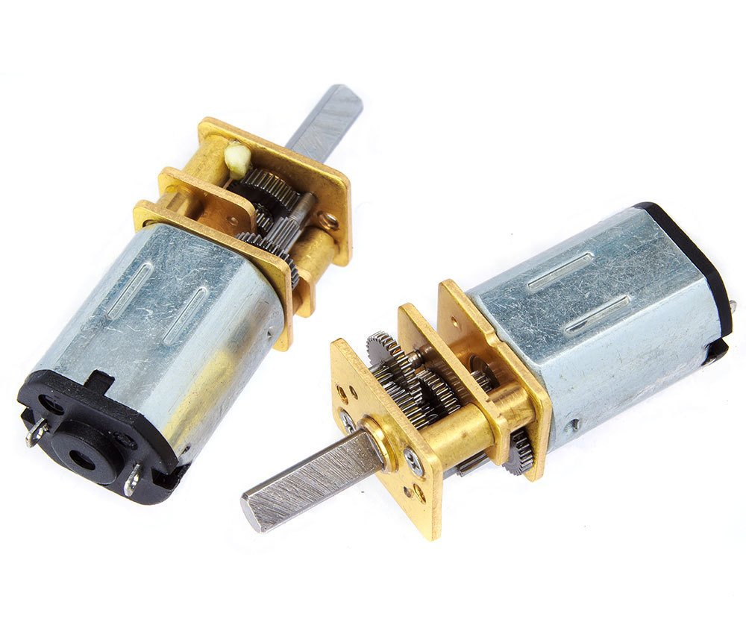

Figure 11: L298N motor driver and DC motor

We are going to use DC Brushed motors and L298N motor driver (H- Bridge). These components are commonly used for this purpose and easy to use and they are illustrated in Figure . DC motors are operating at 6V and 350 rpm in the free-run speed and works with 60mA continuous current. The maximum forcing current for the motors are 1.3A and the maximum torque to be obtained is 1.8 kg-cm [4]. L298N is used for driving these 2 DC motors synchronously. It is suitable for our project with the specifications that it has current capacity for each motor up to 2A and 6V-15V motor driving capability. It also has lots of analog and digital I/O ports which will be connected to controller via jumper cables easily.

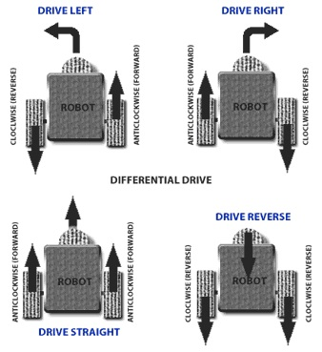

Figure 12: Robot movements with 2 Motors

In the main chassis movement, there are two DC motors, two wheels, one free turning wheel and one DC motor driver. Two wheels connected to DC motors are implemented to the left and right sides of the robot. Free turning wheel is implemented to the front side of the robot. The movements will be achieved by the differential wheels.

Operation principle of differential wheels are simple. If both the wheels are driven in the same direction and speed, the robot will go in a straight line. If both wheels are turned with equal speed in opposite directions, as is clear from the diagram shown in Figure ??, the robot will rotate about the central point of the axis [5]. While turning the robot to one direction, either one motor is driven through forward and other to backward or both in the same direction with different speeds. Since the direction of the robot is dependent on the rate and direction of rotation of the two driven wheels, these quantities should be sensed and controlled precisely.

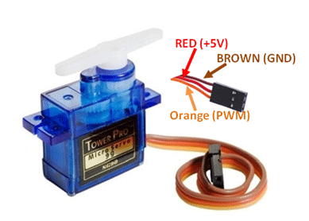

Figure 13: TowerPro SG90 Micro DC Servo Motor

Moreover, we are planning to put servo motor that is connected to camera the on the robot so that we can move the camera to have a better sight. This also plays very important role for the project because we must have as better sight as possible to make proper movements with the robot in order to reach the ball and act on time. TowerPro SG90 Micro Servo will be used for these purposes. It is a low-cost plastic gear RC servo with 1.80kg.cm holding torque (at 4.8V). The servo is illustrated in Figure13 .

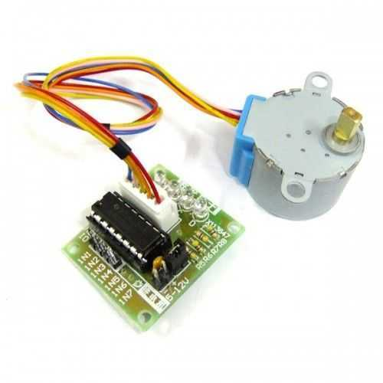

Figure 14: 28BYJ-48 Reducer Step Motor and ULN2003A Step Motor Driver

In the spring system, we are planning to use either a Servo Motor or a Step Motor for triggering system as mentioned in shooting mechanism subsystem part. Coming to servo, we cannot use the aforementioned TowerPro SG90 because its gears are plastic and it cannot be durable for high torques. For this reason, we need to find a better servo regarding out budget and it is a Plan B operation.

For main use, we will use 28BYJ-48 reducer step motor and ULN2003A step motor driver. This motor is cheaper and torque and current ratings are suitable for our operation. The motor and driver is illustrated in Figure14.

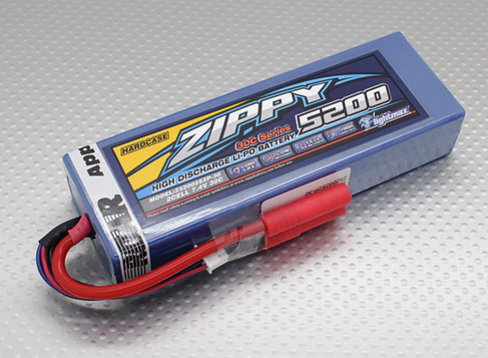

Figure 15: ZIPPY Flightmax 5200mAh 2S2P 30C LiPo battery

For power supply, we will use LiPo battery. LiPo battery is the most convenient one because it has higher energy/weight rate, energy/volume rate, high voltage, and long lifespan. It also keeps for long because of the low self-discharging rate. The LiPo illustrated in Figure15 will be used because it has high discharge capacity of 5200mAh.

In shooting mechanism, stepper motor works when the user gives operate command. The stepper motor draws 300mA and works under 5V. The power consumption is (300mA)2/5V = 0.45W per shot.

In camera movement, the servo motor draws 70 mA in average under 6V. The power consumption is 6V*0.07 A= 0.42 W. Note that this is not the average value because servo will be operating when it is needed to move the camera.

In transmission, P(Transmitter (@ 600mW output power))=3.5W, P(Camera)=1W, P(Receiver)=1W. These values are taken from the datasheets of corresponding components.

In movement subsystem, each motor draws 0.5 A in average under 6V when they are in operation. The DC motors work in 80% of the time. 6 V* 0.5 A*0.8*2= 4.8 W.

High capacity of the battery allows robot to play for minimum working time objective easily. However, if we need to make changes due to the economic concerns or operational easiness, we may continue with different battery.

## 3.5. Control Subsystem

### 3.5.1. Problem Statement and Requirements

The main purpose of the control system is to process the data coming from sensors and receivers to generate the required motor commands for all DC motors. These motors are required to control the two variables as angle of view of the camera and positioning of the robot. The DC motor in the shooting mechanism also needs to be controlled when the shooting signal arrives.

### 3.5.2 Main Solution Procedure

Control subsystem consists of two parts. One is remote control devices and the other one is microcontroller. For the remote-control devices, we have two solution approaches. The first one is using 6-Ch RC Transmitter & Receiver. We are planning to use 2 channels for controlling the robot movements, 1 channel for adjusting the camera angle, and the last channel for shooting. This device quite practical and convenient for the project. It is in low power consumption for durable using. It also has high receiving sensitivity.

For the on-board control purposes, the use of a microcontroller is inevitable. In the market, there are so many different microcontroller boards with different properties. Due to its simplicity and popularity, we are planning to use Arduino NANO. It has clock frequency of 16MHz, variable input voltage between 7 and 12V, analog input pins and PWM output pins, apart from the digital GPIO pins. The Arduino NANO is shown in Figure16.

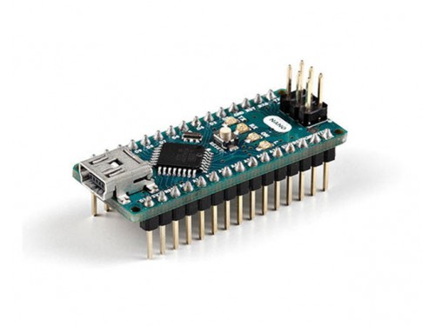

Figure 16: The Arduino NANO with the GPIO pins soldered to the male headers

The main mission of the Arduino is to get the signal (sent by the user through RC transmitter) from the receiver and generate the required motor commands according to instructions. These instructions will come from the 4 channels of the RC transmitter and delivered to the Arduino via receiver in the form of a square wave. These 4 signals have the period of 20 ms and their duty cycle vary depending on the position of the joysticks in the RC transmitter. When the joystick is at the maximum position, the transmitted signal has the ON time of 2ms, corresponding to 10% duty cycle. At the minimum position, the ON time is 1ms resulting in the duty cycle of 5%. Thus, by calculating the ON time of the incoming 4 signals, the Arduino will generate the desired motor commands. These signals will be delivered to the motors accordingly. In the case of the main DC motors, which are responsible for the positioning of the robot, the motor command will change instantaneously in analog manner according to the incoming signals. This action is valid for the Servo motor as well, the purpose of which is to rotate the FPV camera. However, in case of the shooting action, since the motor inside the shooting mechanism does not need to turn continuously, the motor command will be generated for some period, according to the digital shooting signal.

To sum up, control subsystem’s function is that RC Transmitter sends the signals to the receiver that is on the robot, then the receiver generates pulses and sends them to the microcontroller and finally microcontroller interprets these signals and generate commands for the robot. At the end, the robot moves according to the instruction that is sent by the operator and shoots the ball whenever the shoot button is pressed on the RC transmitter.

### 3.5.3. Test Results and Alternative Solutions

We have tried the NANO to control different kind of motors that we are planning to utilize in this project. According to our trials, it is capable of controlling the 2 DC motors with different rotation directions and speeds at the same time with the L293 motor driver. Since the NANO has 8-bit DACs, the output PWM can have 255 different level of duty cycle, which is more than enough for our robot. Moreover, due to the built-in servo library in the Arduino IDE, it is very easy to control servo motor, using NANO.

The RC controllers are very easy and fun to use. Moreover, they can be replaced with any RC transmitter since they are using a universal communication protocol. However, despite all these advantages, it is quite costly when we consider budget limit. Therefore, we have another solution for remote control. The solution is building our own 7 channel RC transmitter and receiver using 2 NRF24L01 RF Transceiver IC and 2 Arduino NANO. The NRF24L01 is a highly integrated, ultra low power (ULP) 2Mbps RF transceiver IC for the 2.4GHz ISM (Industrial, Scientific and Medical) band. This frequency band is the same with the one in the first solution. It enables the implementation of advanced and robust wireless connectivity with low cost 3rd-party microcontrollers. The microcontroller will be Arduino NANO. This solution will decrease the cost for remote control part. Therefore, we will be able to allocate some budget for the other parts of the robot.

The Arduino NANO is a small and lightweight microcontroller board. But considering the sensors, motors and receiver connections, it may not be enough in terms of the output pin number. In that case, we will switch to Arduino UNO, which has 20 GPIO pins while the NANO has 14 of them. Another alternative for the microcontroller board is Tiva TM4C123GXL. It has built in 12 bits ADC, 80MHz of clock frequency and 12 timers. Obviously, it is much more powerful than the NANO but there is a trade-off between quality and the cost.

## 3.6. Sensor Subsystem

### 3.5.1. Problem Statement and Requirements

The robot should not cross the midfield line according to the game rules. To prevent that, we are planning to use a color sensor, which is TCS3200 in this case. Also, the robot should not hit the walls. For this purpose, we will use a distance sensor which should works fine with from the distances between 0-20 cms.

### 3.5.2 Main Solution Procedure

Since the robot is expected to not cross the lines, we will be using a color sensor. The color sensor product provides RGB (Red, Green, Blue) light sensors for precise color measurement, determination, and discrimination. We are going to use the color sensor to identify center-line and goal lines marked by “masking tape” because the robot is forbidden to pass on center-line and get behind the goal line. We will include distance measurement sensor which is HCSR-04. It is the most well-known and available distance measurement sensor. This ultrasonic sensor has a 3mm sensitivity and 2-400 cm range. It can be used in distance measuring, radar and robot applications. We are planning to use this sensor to measure distance between the robot and the walls so that the robot does not hit the wall. Using the data coming from the sensor, the robot will take action immediately if it gets very close to a wall.

### 3.5.3. Test Results and Alternative Solutions

We have tested the HCSR-04 and color sensor. HCSR-04 works fine and measures the distances 0 to 100 cms if it does not have any sound absorbing material in front of it. Also, the TCS3200 is tested. It also works wşthout a problem, but it needs to have a good filtering and well-adjusted threshold value.

## 3.7. User Interface Subsystem

In the interaction of the user with the system, we planned to use a controller and monitoring subsystems as user is not allowed to see the playing field with naked eye. The user needs to see the information coming from the robot on a display screen. For this purpose, an AV monitor, a computer monitor, a smartphone or a computer depending on the receiver output. For now, the receiver in the system generates an AV output and we are using an AV monitor to display the video. This setup is tested several times and it is working really well. However, depending on the new receiver tests, we might use a smartphone as displaying screen since it means the cost of the AV monitor will be removed and a smartphone is more common and easy to reach. It will be better to use a smartphone since anyone will be able to play the game anywhere.

For the control of the robot, the user should be able to have a device to steer the robot and issue commands. For this purpose, our main plan is to use an RC controller as mentioned in the Control subsystem part. At first, we were hesitant to use an RC controller since it is very expensive. However, with recent developments in other subsystems reducing the cost, we can use an expensive RC controller. If the budget doesn’t allow, we can build an RC controller by using NRF transmitter receiver system combined with a microcontroller and a joystick. However, a commercial RC controller is much more reliable and user friendly since there will be control buttons for steering of the robot and the camera and shooting requiring different channels for each control. The experiment with an RC controller was performed along with the transmission subsystem in different conditions and the results are even better than the video transmission. The RC controller can send commands with little to no delay up to 100 meters with obstacles between the robot and the user.

# 4. PLANS

## 4.1. Breakdown of The Planned Work

Automata Technologies that is conducting The Hockey Project hires five engineers who specialized in different fields. Workload is allocated among these engineers and each person has different responsibilities and fulfills his or her duties with the help of others. In this way, while each engineer carries out the works of his or her own fields, they are not isolated from the other parts of the project. This plays an important role to conduct the project successfully.

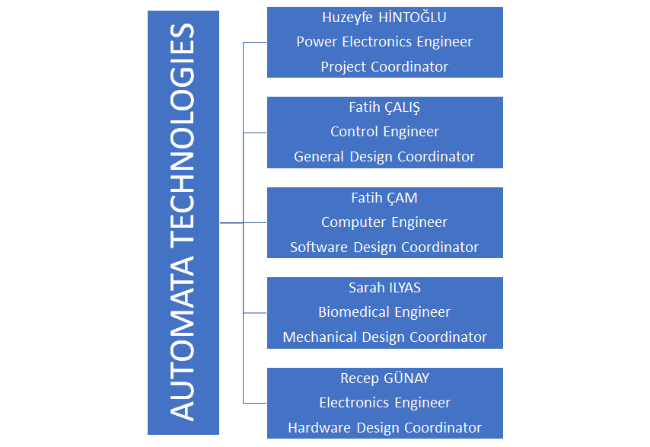Huzeyfe Hintoğlu as a power electronics engineer in the company and he is specializing in power electronics area while taking courses from computer and control areas. He is very experienced in voltage converter design and usage and motor driver. He is also very knowledgeable about control algorithms and applications. He is the general coordinator of the project. He will be responsible for power electronics subset. He will work on power analysis of the robot and decide what power source, voltage regulators, motor drivers and motors will be used in the robot.

Figure 17: Responsibilities among the members

Recep Günay serves as electronics engineer in the company and he is specializing in electronics area while also taking courses from microwave and computer areas. He is quite knowledgeable in programming with different programming languages such as C and Python. He has hands on experience in digital design with Verilog HDL and image processing using Python and Verilog. He is mainly working on hardware design, especially in telecommunication subfield. His responsibility is to provide live video stream. In order to achieve this, he makes a lot of research to decide which camera, receiver, and transmitter should be used to satisfy requirements.

Fatih Çalış serves as a control engineer in the company and he is specializing in control area while also taking courses from computer area. He is very experienced in robotics applications and he built several robots on his own in the past. He is also the most knowledgeable among the company members about the mechanical design of a robot. His main job is the general design of the project. He helps Recep Günay for the other issues of the hardware design, and he is also in coordination with Sarah Ilyas for mechanical design. They work on mechanical design and the shooting mechanism of the robot.

Fatih Çam serves as a software engineer in the company and he is specializing in computer area. He is very experienced in programming with different languages such as C and Python. He is also quite knowledgeable about digital design with Verilog and VHDL. He also has experience with electromagnetics and telecommunication. He is responsible for software subfield and will work on any kind of coding and can work with Recep Günay on the telecommunications part. He will be writing control algorithm of the robot.

Sarah Ilyas serves as a biomedical engineer in the company and she is specializing in biomedical area. She is very experienced in image processing and sensor usage. She is mainly responsible for hardware design of the project. Especially, she is working on sensors, and she will decide what kind of sensors to use and she will work on reading and optimizing the sensor outputs. She is also coordinating with Fatih Çalış for the shooting mechanism of the robot.

## 4.2. Gantt Chart

The time plan for the project is determined by estimating the duration for design, tests and implementation of the subsystems namely, transmission, mechanical, electromechanical & power, control and sensor subsystem. It is more appropriate to spare more time on the transmission and the control subsystem since both of them are considered as the most complex and crucial parts of the project.

The integration of the subsystems will probably lead to some mechanical, interference or wiring problems and therefore, we have spared the last month and a half on the troubleshooting. The Gantchartt created for the project is given in Figure 18.



Figure 18: The Gantt Chart of the project

At this point in the project marked with current time in Figure18, we have designed the transmission subsystem and started the test and implementation of the system with different equipments. We have designed the wireless control of the robot with RC controller and started test and implementation of the system. We have designed the mechanical subsystem including the design of the robot and the shooting mechanism and started to manufacture and test the system. We have designed the electromechanical subsystem including the motors and power systems and will start test and implementation once the components arrive. We have decided on what sensors to use and started test and implementation of the sensor subsystem. The sensor subsystem and the wireless control parts constitute a big part of the control subsystem and it will be finished thereafter. When all the subsystems are designed and tested individually, we will start to integrate the subsystems as a whole and modify the non-operational parts during the troubleshooting phase. Where we are currently in the project affirms us that the project will be finished in the scheduled time with no trouble, hopefully.

## 4.3. Difficulties and Solutions

1. The transmitter we have now is 2000 mW to provide clear, continuous and low latency video transmission to long range. This consumes more power than we probably need. To decrease the power consumption, we will be trying some other transmitter with lower output power. According to results, we will decide which one to use.
2. There is an interference problem caused by the wave portion that reflects from an object. To avoid this, we use an antenna on both the transmitter and receiver with the same polarization direction. This approach prevents interference.
3. There is a trade-off between range and penetration capability in FPV systems in terms of wave frequency. Because it is an indoor project, penetration is an important issue. Also, the project is supposed to work up to 30 meters distance. Considering these two requirements, it is convenient to use a transmitter with 5.8GHz frequency.
4. There is a trade-off between gain and omni-direction in the antenna systems. The more gain an antenna has, the sharper its direction will be, and it will receive signals from other directions in a very small amount. To solve this, we use a diversity receiver with dual-antenna and use one omni-directional antenna with small gain and one directional antenna with high gain combined.
5. There is the risk that the signal will be lost since the robot will move around in all directions. We solve this problem by utilizing an omni-directional antenna on the robot so that the wave will be transmitted at the same power in all directions even if the robot moves.
6. To control the robot, we use Radio Controller. Although the expense of a commercial RC controller is high, it is more favorable than building our own RC controller since the cost of other parts are greatly reduced and a commercial RC controller is more reliable. If the budget will not allow, we can build our own RC controller.
7. Rather than computer screens or phone screens, any screen for video stream is included in the budget. In order to use the budget, we have efficiently, we will try to use a receiver that is compatible with android phones. We can display the video on Android phones using this receiver.,
8. The field of view of the camera is also an important to react to the actions properly. Therefore, the camera will be placed on the top of the robot and will be able to rotate with servo motor to watch the field.

## 4.4. Test Plans and Measures of Success

As measure of success, the following criterias will be considered:

1. The maximum distance for transmitter and receiver can work properly
2. The quality of the video stream to watch the game field
3. The maximum distance for Radio Controller to run the robot properly
4. The duration for the robot taking action and shooting the ball
5. The reaction of the robot when it encounters the goal and the centerline
6. The region in which the ball is bounded after shooting

Test plans for our project have two stages. In the first stage, we have already tested the FPV camera and the Radio Controller to prepare them for the final presentation of this semester. In this demonstration, we are supposed to provide proper video streaming and show that the controller works properly up to desired distance. The test results are successful. The FPV camera was able to transmit video stream with enough quality in indoor area and the radio controller worked well and we were able to control a servo motor with that from a long distance. In the second stage, we will construct the robot and then test if it works properly. In this part, the movement capabilities of the robot that is controlled by the Radio controller, the reaction of the robot to the goal line and center line, shooting mechanism of the robot will be tested.

## 4.5. Integration Plans

* Chassis of the robot will be constructed first. The controller and the sensors will be placed on the robot. The data will be read from the sensor and checked.
* Wheels and motors will be mounted on the chassis and the stability of the wheels will be tested. Motors will be driven by the controller and they will be checked if they work as desired.
* Camera and the transmitter will be placed and the setup for the receiver and display part will be constructed. Live video stream will be checked.
* Shooting mechanism will be integrated. It will be spring based mechanism and will be trigger by a motor. It will be checked if it works properly and gives enough speed to the ball
* After these steps, the robot will be ready to play the game.

## 4.6. Cost analysis

A budget analysis is made considering the most expensive and the cheapest of every component. The components of which we are not certain can be chosen according to this analysis. The above-mentioned budget analysis is shown in Table 1.

The price of the mechanics of the robot is not included in the analysis since it is not certain how we will implement the physical mechanisms of the robot yet. The price for the mechanics left if all the components are bought with the minimum price is 79$ which is more than enough for the robot. However, with the most expensive equipment, the budget is exceeded even without the mechanics included. Therefore, some parts of the system that are not very critical should be chosen with the minimum price while more important parts should be chosen with a reasonable quality to make space for the mechanics of the robot. This budget analysis forces us to design the RC controller ourselves since the products on the market are too expensive. The FPV camera we experimented with is a high-quality camera belonging to a very famous brand called FatShark and it is too expensive. Also, it works with a very narrow voltage range which forces us to use a voltage converter increasing the price. We are looking for the ones that are cheaper, lower video quality and wider angle to see more area in the field.

In order to choose all the components, we will first try to obtain some products without spending money and experimenting with them under different conditions. When we are convinced that the components will most probably work, or we cannot procure some of the products without buying them, we will buy the components and experiment with them. While choosing the best components for our project, we will also make research about the mechanics of the robot. When the shape of the mechanics become clearer, we will have a better estimation of its price and we can add what is left of its expected budget to other components to increase the quality of the system.

|  |  |  |
| --- | --- | --- |
| **Component** | **Minimum Price** | **Maximum Price** |
| Video Transmitter | 11 $ | 16 $ |
| Video Receiver | 15 $ | 28 $ |
| AV Monitor | 15 $ | 25 $ |
| FPV Camera | 10 $ | 50 $ |
| RC Controller | 20 $ | 50 $ |
| Battery | 10 $ | 30 $ |
| DC Motor (x2) | 5 $ | 15 $ |
| Servo Motor (x2) | 2 $ | 10 $ |
| HC SR04 (x4) | 1 $ | - |
| Line Follower Sensor(x4) | 2 $ | - |
| Motor Driver | 5 $ | 10 $ |
| Wheels(x2 or x4) | 1 $ | 6 $ |
| Ball | 2 $ | - |
| Walls | 5 $ | - |
| Total | 121 $ | 322 $ |

*Table1: A rough budget analysis showing the price of every component.*

## 4.7. Deliverables

### Equipments

***Vehicle (Robot)***

● The user will be provided with a robot to compete with another robot on the play field.

***Play Field***

● The user will be provided with a robust hexagonal play field on which two robots can play hockey.

***Ball***

● The user will be provided with a ball whose specifications will be decided later in standard committee meetings.

***Goals***

● The user will be provided with two goals for each player with the play field.

***Control Interface***

● The user will be provided with a control interface system consisting of a RF transmitter to send commands and a screen to watch the video coming from the robot for decision making.

### Documents

***Warranty***

● Automata Technologies provides a two-year warranty in the event of a failure in the hardware or the software part of the robot except in a user fault case.

***Manual***

● The user will be provided with a manual on how to operate the robot using the RF transmitter and to set up the control interface.

### Software

***CD***

● The user will be provided with a CD containing the manual in a tutorial manner in both video and document formats.

# 5. CONCLUSION

In the realm of teleoperated robotics, there has been an ever-increasing demand for contraptions that can help users achieve more, we at Automata Technologies strive to take quantum leaps in the right direction by integrating innovation with cutting edge technology and thorough research. This venture, wherein we shall devise a strategy and design a teleoperated robot is just another case in point. The demands laid out by our clientele are the focal point of our endeavors. By virtue of this document we have shed on each subsystem of our robot,including the transmission, mechanical electromechanical,power, control and sensory subsystems. A lot of thought and planning was invested in the design and selection of each individual sub- block of our project; from the selection of an apt camera that would depreciate latency to choosing an acquisite shooting mechanism that would not be hefty, each individual component was winnowed out from a plethora of other choices after conscious planning, deliberation and research. The centerpiece of our transmission subsystem is the FPV camera; a 5.8 GHz FPV camera, after thorough research was found to be well- suited for our needs, in addition, a FPV transmitter and receiver would ensure uninhibited video streaming. Remote control devices, we have two solution approaches. The first one is using 6-Ch RC Transmitter & Receiver. For remote control, we intend to utilize 4 channels in order to control the locomotion of our robot, the first channel would be used for camera angle adjustment while the last one would be employed for shooting. The sensor subsystem would employ RGB (Red, Green, Blue) light sensors for precise color measurement, determination, and discrimination. Therefore, for our prospective clients, we offer a versatile product. This product may be employed by disparate people, from sport coaches to ALS patients. As pioneers of this company, this is one of the very first technological enterprises we have undertaken and one of our aspirations is to offer the most innovative solution to our consumers. As a nascent and budding company, we are very conscious of the impact we make on our environment; one of the preliminary standards of our company is to ensure that our products create no adverse environmental effects. Conclusively, we at Automata Technologies believe that our product will live up to the clients’ expectations and its accomplishment will be a notch on our belts.

# 6) DISCLAIMER

Those who sign this report confirm that the design complies with the standards of the selected project.

Fatih ÇALIŞ Fatih ÇAM

Recep GÜNAY Huzeyfe HİNTOĞLU

Sarah ILYAS

# 7) REFERENCES

[1] Jayakody, Dushantha Nalin K.; Thompson, John; Chatzinotas, Symeon; Durrani, Salman (2017-07-20). *Wireless Information and Power Transfer: A New Paradigm for Green Communications.* Springer.

[2] S.M. Lindenmeier, L.M. Reiter, D.E. Barie and J.F. Hopf. *Antenna Diversity for Improving the BER in Mobile Digital Radio Reception Especially in Areas with Dense Foliage*. International ITG Conference on Antennas

[3] Balanis, C. A. (2005). *Antenna theory: Analysis and design* (3rd ed.). Hoboken, NJ: John Wiley.

[4] ‘6V 350Rpm Redüktörlü Mikro DC Motor.’ (n.d.). Retrieved from https://www.robotzade.com/6V-350Rpm-Reduktorlu-Mikro-DC-Motor,PR-1171.html

[5] G.W. Lucas, *A Tutorial and Elementary Trajectory Model for the Differential Steering System of Robot Wheel Actuators*,Rossum Project